General Skills

1.Obident Cat

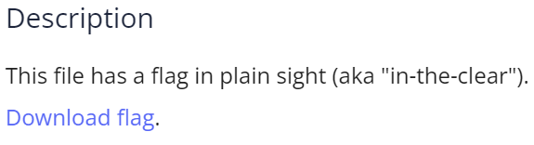

Solution: using cat and grep command.



Flag: picoCTF{s4n1ty_v3r1f13d_28e8376d}

### 2. Python Wrangling

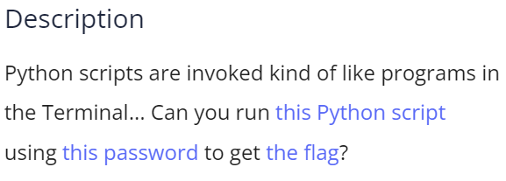

Solution: on inspecting the python script we see the code to decrypt.



Using the password in pw.txt and the above command we get the flag.

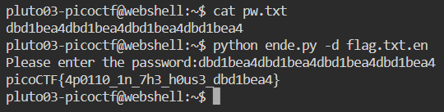

Flag: picoCTF{4p0110_1n_7h3_h0us3_dbd1bea4}

### 3. Wave a flag

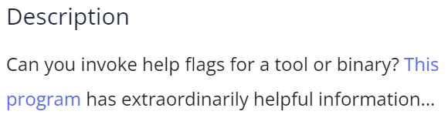

Solution: using strings and grep command.

Flag: picoCTF{b1scu1ts_4nd_gr4vy_18788aaa}

### 4. Nice netcat...

### 

### 

### This gives a list of ASCII numbers. Using online ASCII to text converter.

### 

### Flag: picoCTF{g00d_k1tty!_n1c3_k1tty!_d3dfd6df}

### 5. Static ain't always noise

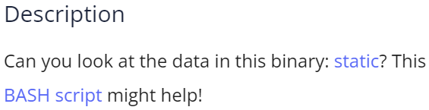

Solution: read the BASH script with static argument

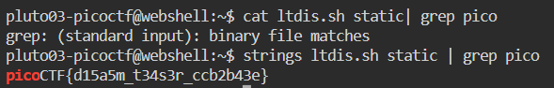Flag: picoCTF{d15a5m_t34s3r_ccb2b43e}

### 6. Tab, Tab, Attack

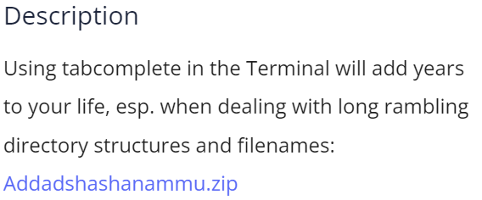

Solution: unzip the file. Follow the instructions and use tab.

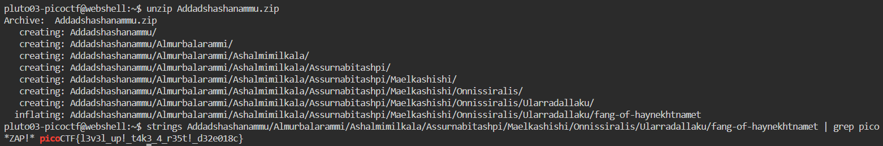

Flag: picoCTF{l3v3l_up!_t4k3_4_r35t!_d32e018c}

### 7. Magikarp Ground Mission

### 

### Solution:

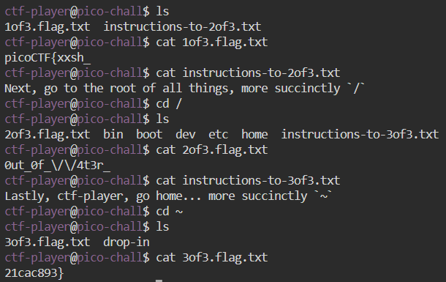

Flag: picoCTF{xxsh_0ut_0f_\/\/4t3r_21cac893}

8. Lets Warm Up

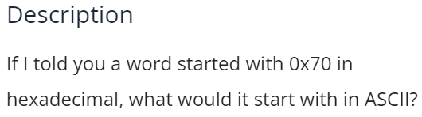

Solution: using online hex to ASCII converter



Flag: picoCTF{p}

### 9. Warmed Up

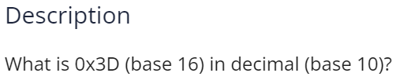

Solution: using online hex to decimal converter

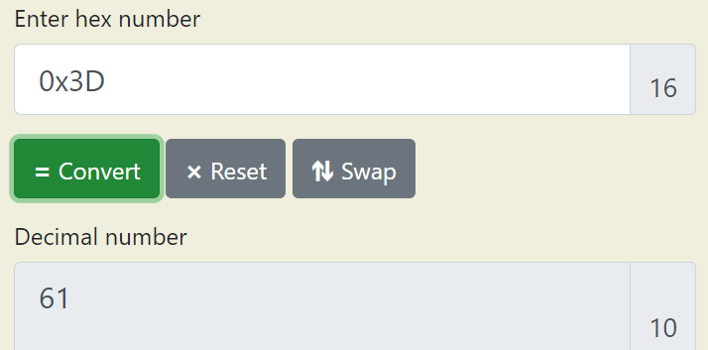

Flag: picoCTF{61}

### 10. 2Warm

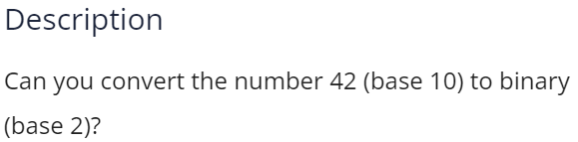

Solution: using online decimal to binary converter

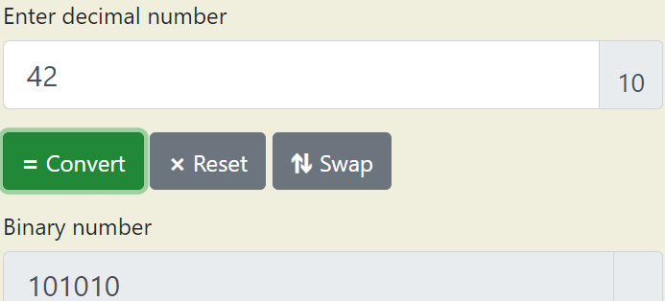

Flag: picoCTF{101010}

### 11. what's a net cat?

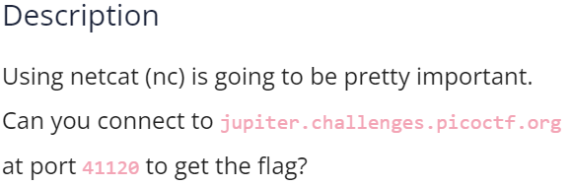

Solution: connect using netcat

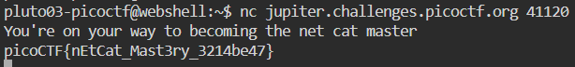

Flag: picoCTF{nEtCat_Mast3ry_3214be47}

### 12. strings it



Solution: using strings command



Flag: picoCTF{5tRIng5_1T_7f766a23}

### 13. Bases

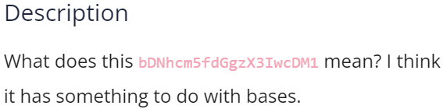

Solution: The data seems to be Base64 encoded. Using online decoder

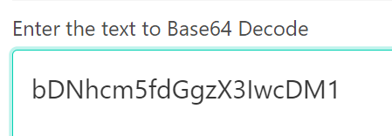 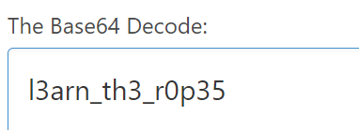

Flag: picoCTF{ l3arn_th3_r0p35}

### 14. First Grep



Solution: using grep command

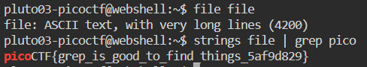

Flag: picoCTF{grep_is_good_to_find_things_5af9d829}

### 15. Codebook

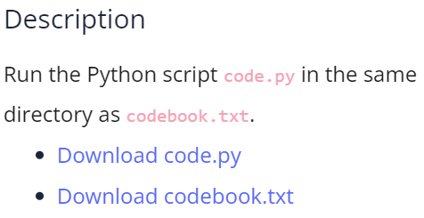

Solution: Download both and run.



Flag: picoCTF{c0d3b00k_455157_d9aa2df2}

### 16. convertme.py

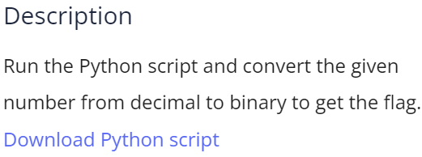

Solution: run the script and answer the question.

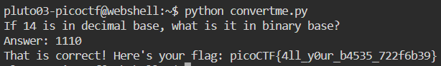

Flag: picoCTF{4ll_y0ur_b4535_722f6b39}

### 17. fixme1.py

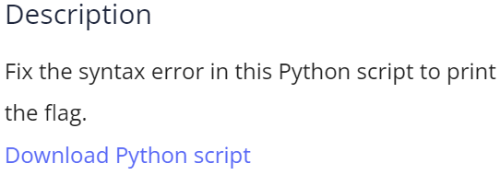

Solution: On examining the code we can see the indentation error.

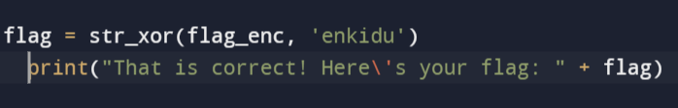

After correction execute the code.

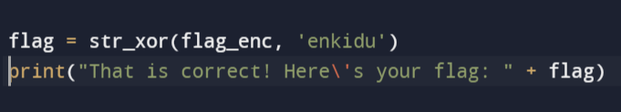



Flag: picoCTF{1nd3nt1ty_cr1515_6a476c8f}

### 18. fixme2.py

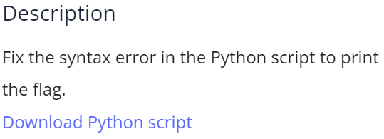

Solution: On examining the code, we can see the use of assignment operator instead of equality operator.

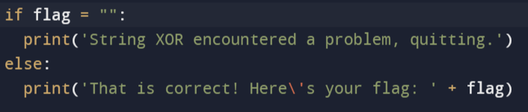

Execute after correction to get the flag.

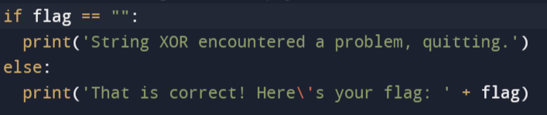

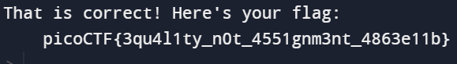

Flag: picoCTF{3qu4l1ty_n0t_4551gnm3nt_4863e11b}

### 19. Glitch Cat

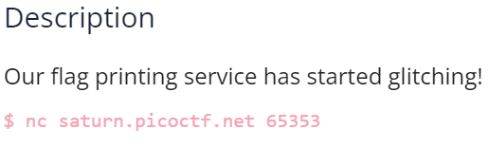

Solution: connect using netcat. We get the flag but some of the letters are in hex code.



Write a python code to print the flag.

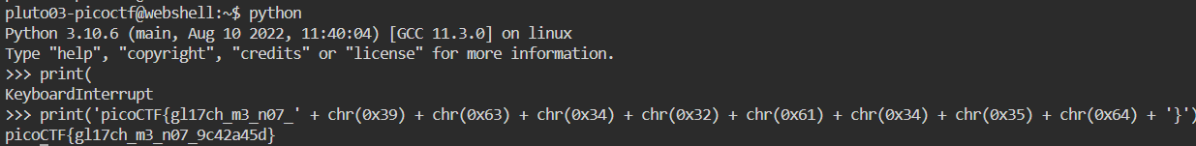

Flag: picoCTF{gl17ch_m3_n07_9c42a45d}

### 20. HashingJobApp

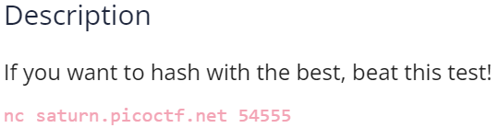

Solution: connect using netcat and answer the questions using online md5 hash generator.

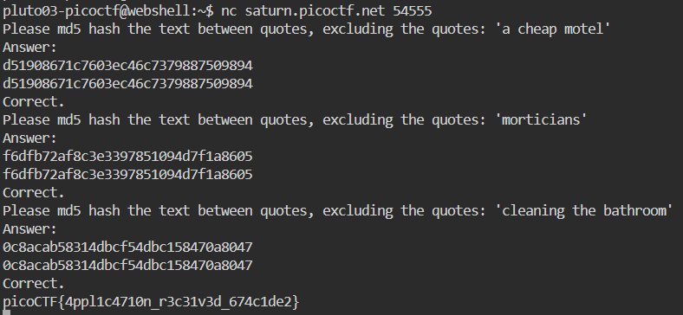

Flag: picoCTF{4ppl1c4710n_r3c31v3d_674c1de2}

### 21. PW Crack 1

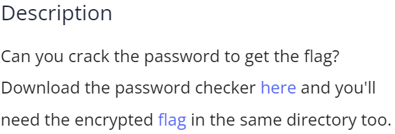

Solution: On inspecting the python code, we get the password.



Run the python code using the found password.

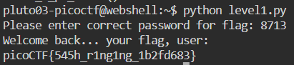

Flag: picoCTF{545h_r1ng1ng_1b2fd683}

### 22. PW Crack 2

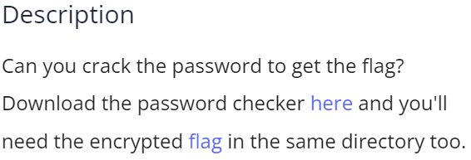

Solution: On inspecting the python code, we find the password in hex code.



Write a code to print it in words.

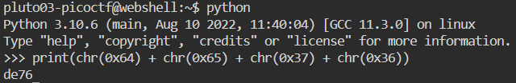

Now using the obtained password, execute the python code.

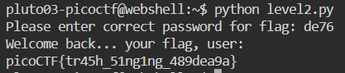

Flag: picoCTF{tr45h_51ng1ng_489dea9a}

### 23. PW Crack 3

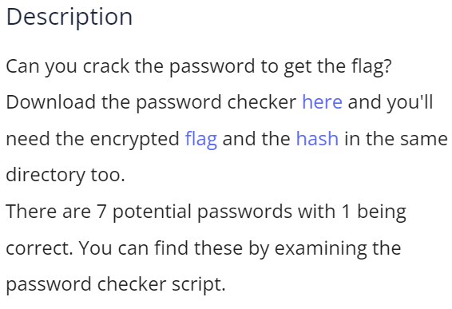

Solution: On inspecting the password checker code, we find 7 possible values.

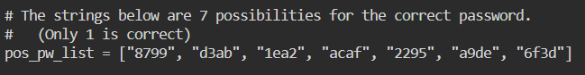

Run the code and try the 7 passwords. 1 of them will give the flag

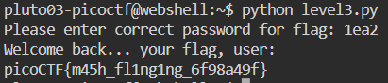

Flag: picoCTF{m45h_fl1ng1ng_6f98a49f}

### 24. runme.py

### 

### Solution: Download and run the python code

### 

### Flag: picoCTF{run_s4n1ty_run}

### 25. Serpentine

### 

### Solution: On inspecting the code we find that choice b does not print the flag.

### 

### Now change the code and execute it.

### 

### 

### Flag: picoCTF{7h3_r04d_l355_7r4v3l3d_8e47d128}

### 26.First Find

### 

### Solution: unzip the file. The require file is visible. Open it.

### 

### Flag: picoCTF{f1nd_15_f457_ab443fd1}

### 27. Big Zip

### 

### Solution: unzip the file and grep the flag

### 

### Flag: picoCTF{gr3p_15_m4g1c_ef8790dc}

### 28. Based

### 

### Solution: connect with netcat and answer the questions using a converter.

### 

### Flag: picoCTF{learning_about_converting_values_b375bb16}

### 29. plumbing

### 

### Solution: connect using netcat. Save the contents of this in another file. Search that file for the flag.

### 

### Flag: picoCTF{digital_plumb3r_5ea1fbd7}

### 30. mus1c

### 

### Solution: using online rockstar interpreter we get a sequence of ASCII numbers

### 

### Using online ASCII to text converter

### 

### Flag: picoCTF{rrrocknrn0113r}